DATE TIME MODULE
datetime module
The datetime module has several classes to work with different aspects of date and time:
- date: To work with dates (year, month, day).
- time: To work with times (hours, minutes, seconds, microseconds).
- datetime: Combines both date and time.
- timedelta: Represents the difference between two dates, times, or datetimes.
- tzinfo: Base class for dealing with time zones.

Methods in datetime module
datetime.today()
Returns the current local date and time, without time zone info.

datetime.now()
Returns the current date and time with optional timezone information.
datetime.utcnow()
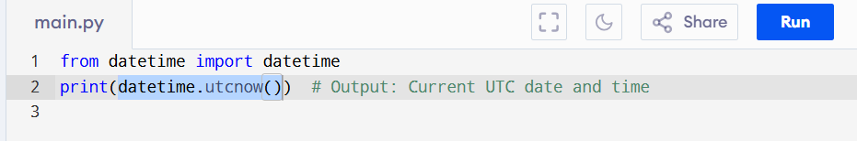
Returns the current UTC date and time.

datetime.fromtimestamp()
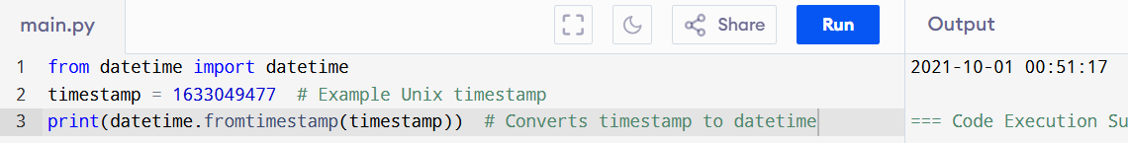
Converts a timestamp (seconds since the epoch) to a datetime object.

datetime.strptime()
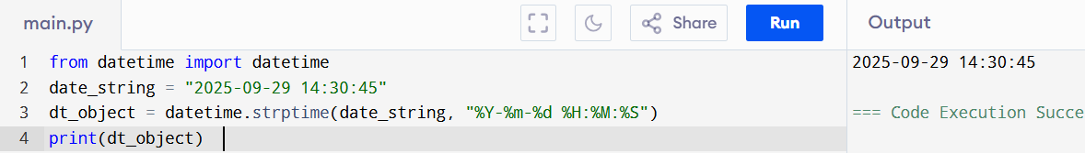
Parses a string representing a date and time into a datetime object, based on a given format.

datetime.strftime()
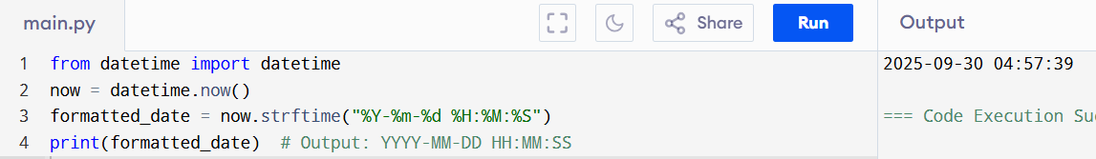
Converts a datetime object into a string representation, based on a specified format.

datetime.date()
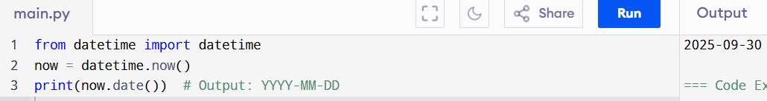
Extracts the date part (year, month, day) from a datetime object.

datetime.time()
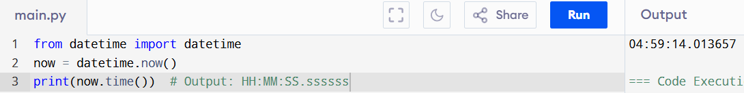
Extracts the time part (hours, minutes, seconds) from a datetime object.

datetime.date
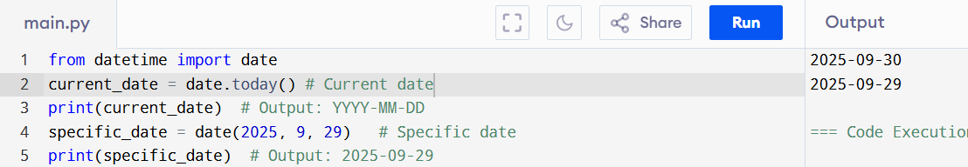
Represents a date (year, month, and day) without the time component.

datetime.time
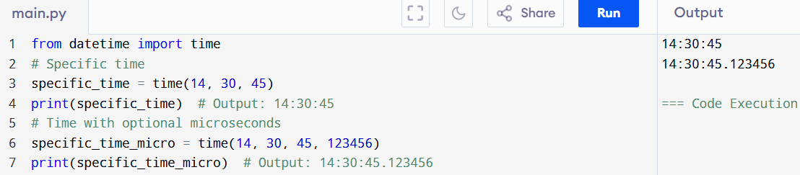
Represents a time object without the date component (hours, minutes, seconds, and microseconds).

datetime.datetime
Represents both a date and a time.
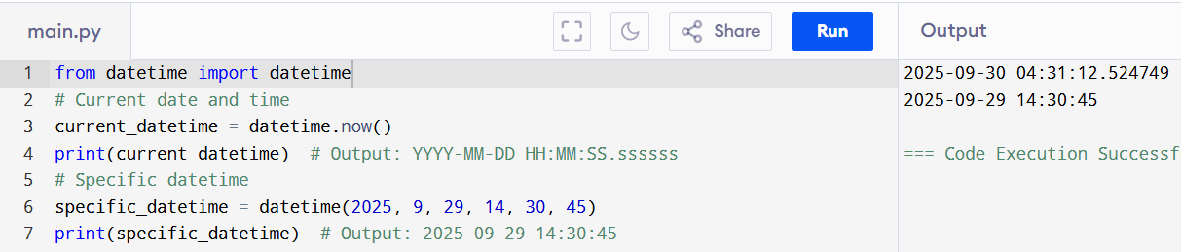

datetime.timedelta
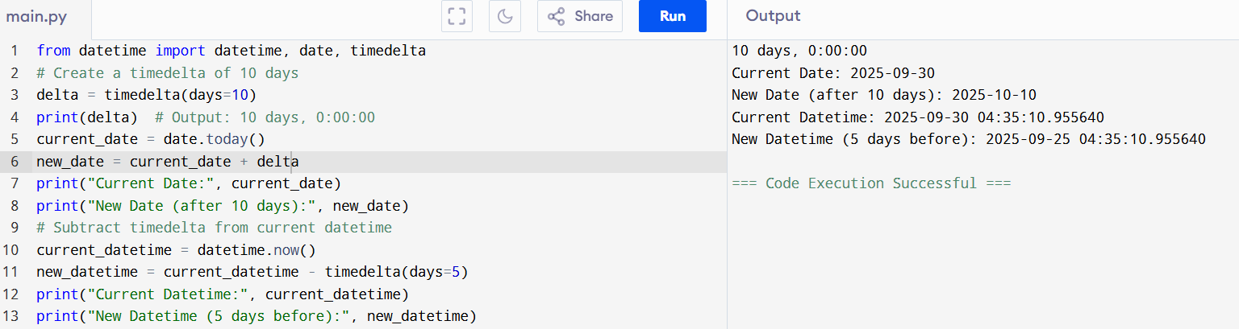
Represents the difference between two dates or times.

datetime.tzinfo
Used for handling time zone information, typically subclassed to handle specific time zone logic.
# Example requires using timezone-aware datetime objects.
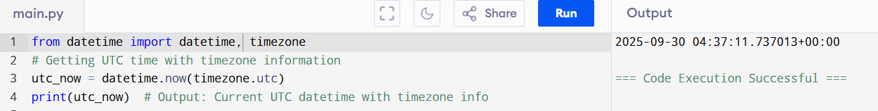

4. Time Zone Handling with datetime
Python’s datetime module can work with time zones through the timezone class. Time zone-aware datetimes are important when you want to manage datetime across different locations.
Creating Timezone-Aware datetime Objects
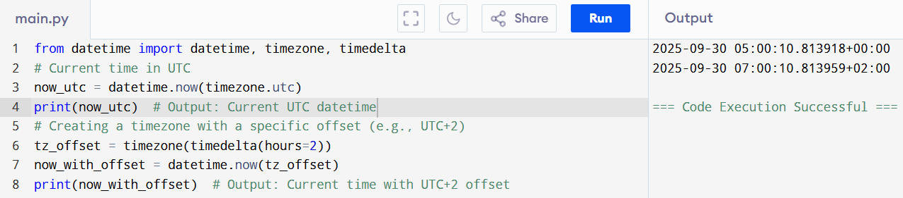

5. Example Use Case: Working with Dates and Time
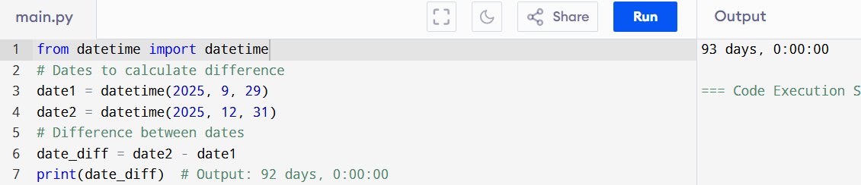
Calculate Date Difference

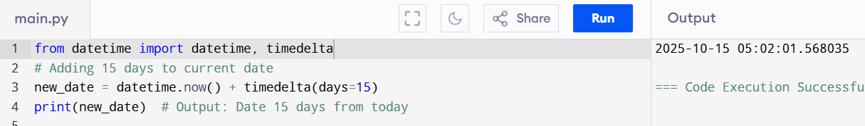
Adding Days to a Date

Get the Current Time in Different Formats
